A000-US-MA-Boston-American Chestnut Bottle-Raw Silicon-1750-1850

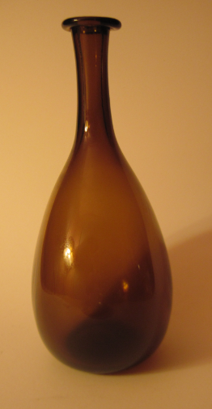 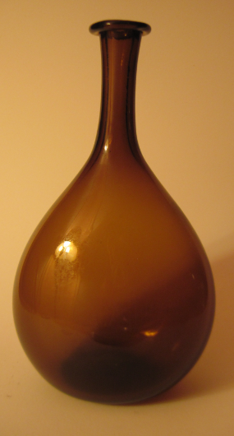

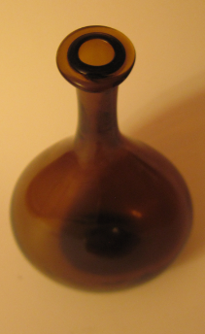 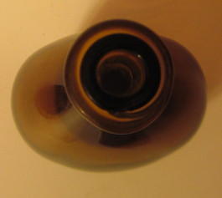

**Case no.: 12**

**Accession Number:**

**Formal Label:** US-MA-Boston-American Chestnut Bottle-Raw Silicon-1750-1850

**Display Description**:

The most common type of glass bottle in the colonies the time of the American Revolution was the American Chestnut Bottle, a free-blown, American chestnut-colored, pleasingly bulbous glassware at a time when American chestnut trees were in great abundance on the landscape before their extinction and before the extinction of the American Chestnut Bottle like their tree namesake as well. These bottles were made by northern colonial glass shops from about 1750 to 1850 in a spectrum of colors from olive green to chestnut brown depending on the sand used. They ranged from 4 to 12 inches in height (McKearin 1948, pl. 225, Spillman 1983, no.45).

The proportionality of the stem to the height ranging from 25 % to 50% of their height was critical in this long-stem example because measuring was made easy to pour by ounces. One could not pour out a continuous stream of liquid because this was prevented by the length of the stem: each ejection of a fluid from the flask was nearly the same no matter what amount was left, and this was ensured by the second lip of dark glass inserted in the mouth by the glassblower as one of the three last steps. In order to pour out approximately 2 ounces, 10 ejections of liquid were necessary. Of course, these were simple numbers to remember and multiply, especially by a tavern keeper or barmaid in a dimly lit tavern. A great selling point. The final two steps of the glassblowing were to depress the center of the bottom with a rectangular instrument to ensure a secure base and then to grind the remaining uneven places on the long side of the base.

**LC Classification:**

**Date or Time Horizon:** 1750-1850

**Geographical Area:** Boston, Massachusetts

**Map:**

**GPS coordinates:**

**Cultural Affiliation:** Massachusetts Colony Glassblowers

**Medium:** raw silicon

**Dimensions:** Opening at lip--1.47 in, 36.72 mm; Opening at mouth--0.55 in, 14.04 mm; Height 8.82 in, 223.94 mm; Approx. length of stem-- 2.97 in; 75.36 mm; Maximum Width on bulbous side-- 5.03 in; 127.74 mm; Maximum width on ground base-- 2.44 in, 61.96 mm; Rectangular glass punch on base--Width 0.63 in, 16.00 mm, Height 0.58 in, 14.72 mm; Ratio of Length of Stem to Height—.336.

**Weight:**

**Condition:**

**Provenance:** The Hilary Family, Bevery, Massachusetts

**Discussion:**

**References:** from American Glass, [Ancient Glass Blog of The Allaire Collection](https://ancientglass.wordpress.com/)

Mc Kearin, Helen. 1978. American Bottles and Flasks and their Ancestry. New York: Crown Publishers.

Mc Kearin, George and Helen. 1950. Two hundred years of American blown glass. Garden City, NY.

Mc Kearin, George and Helen. 1948. American Glass. New York: Crown Publishers.

Palmer, Arlene. 1989. Glass in early America: selections from the Henry Francis du Pont Winterthur Museum. Winterthur, DE: Winterthur Museum; New York: Distributed by Norton.

Palmer, Arlene. 1989. The Wistars and Their Glass 1739-1777. Millville, NJ: Museum of American Glass at Wheaton Village.

Spillman, Jane. 1982. Glass Vol. 1, *Tableware, Bowls & Vases*. New York: Knopf.

Spillman, Jane. 1983. Glass Vol. 2, *Bottles, Lamps & Other Objects*. New York: Knopf.

**Appendix:** from the [Ancient Glass Blog of The Allaire Collection](https://ancientglass.wordpress.com/)

The three examples from the Allaire collections are:

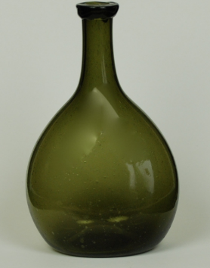

05A Chestnut Bottle H: 5 7/8″

05A Chestnut Bottle H: 5 7/8″

This is a dark olive green American chestnut bottle with pushed-up base.  Plain applied lip.

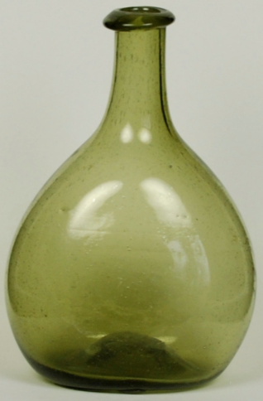

25A Chestnut Bottle H: 5 ½ inches

25A Chestnut Bottle H: 5 ½ inches

This free blown American chestnut bottle is olive green with pushed-up base and plain applied lip.

[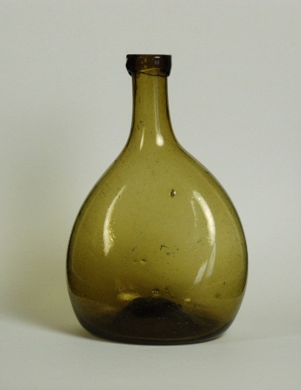](https://ancientglass.wordpress.com/2013/03/11/american-chestnut-bottle/33a-chestnut-bottle/)

33A Chestnut Bottle H: 5 ½ inches

33A Chestnut Bottle H: 5 ½ inches